HYPOTHESIS TESTING AND CORRELATION:

1. HYPOTHESIS TESTING:

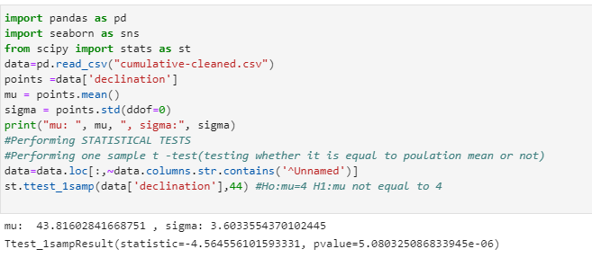

In the one sample t-test, we are taking Ho and H1 as (Ho: mu = 44 and H1: mu not equal to 44)

We got p-value as 5.0803e-06, which is less than 0.05 (alpha), hence null hypothesis is rejected.

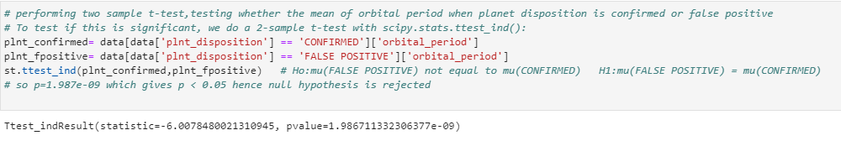

In the two sample t-test, we are taking Ho and H1 as (Ho: mean of orbital period of planet dispositioned as CONFIRMED and mean of orbital period of planet dispositioned as FALSE POSITIVE are different AND H1: mean of orbital period of planet dispositioned as CONFIRMED and mean of orbital period of planet dispositioned as FALSE POSITIVE are same)

We got p-value as 1.987e-09, which is less than 0.05 (alpha), hence null hypothesis is rejected

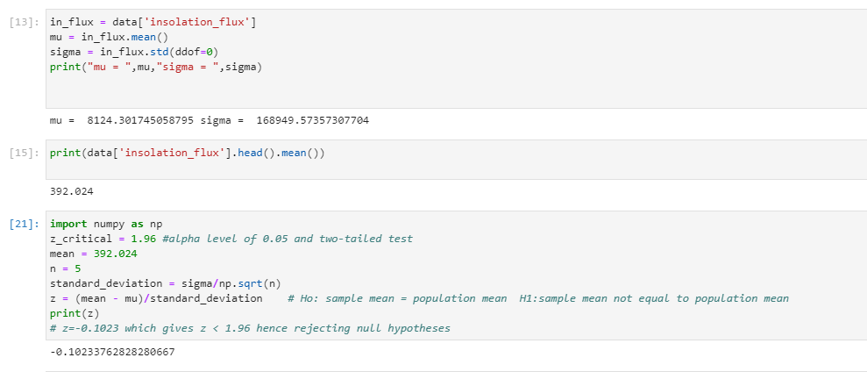

Testing on population mean, here we are taking Ho and H1 as (Ho: sample mean of insolation flux is equal to population mean AND H1: sample mean of number of insolation is not equal to population mean)

We got z-value as -0.1023, which is less than 1.96, hence null hypothesis is rejected

CORRELATION:

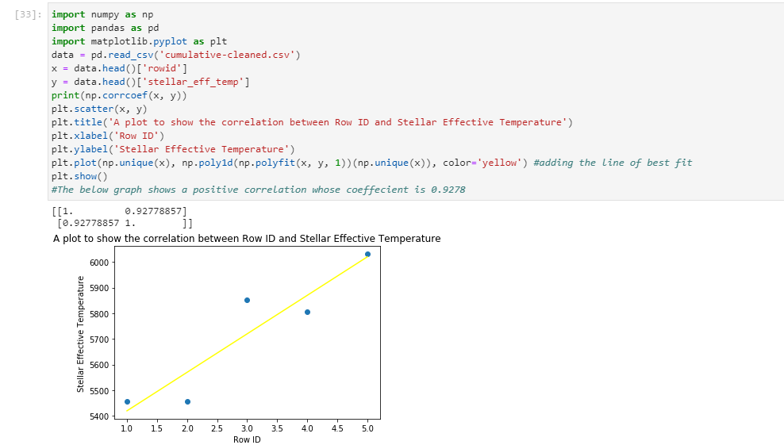

The above is a scatter plot of positive correlation with a coefficient of 0.927. Here, the two variables move in the same direction (i.e., one variable increases as the other increases or, one decreases as the other decreases).

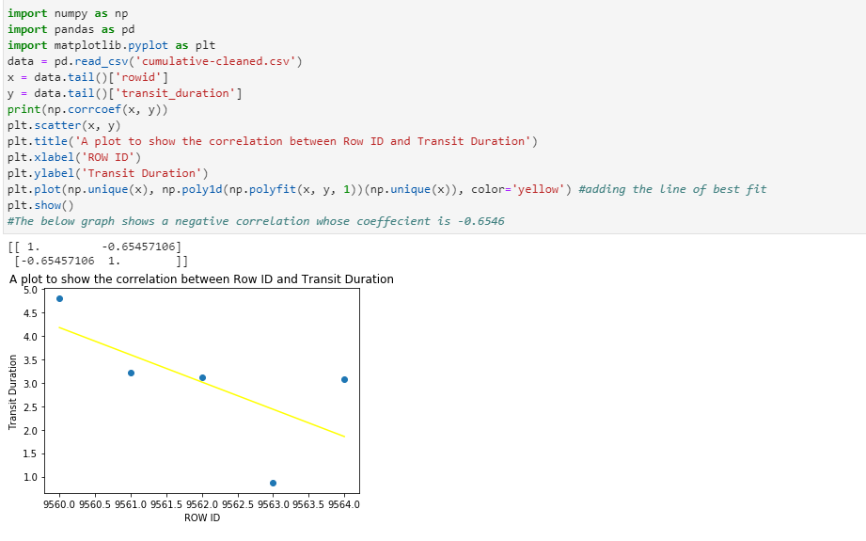

The above is a scatter plot of negative correlation with a coefficient of -0. 6545.Here, the two variables move in opposite directions (i.e., one variable increase as the other decreases, and vice versa).